**“A WEB-BASED INTELLECTUAL PROPERTY DATA MANAGEMENT SYSTEM (IPDMS) IN MINDANAO STATE UNIVERSITY - MARAWI CAMPUS”**

A Capstone Project

presented to the Faculty of the

College of Information and Computing Sciences in

Mindanao State University

In Partial Fulfillment of the Requirements

for the degree of Bachelor of Science in Information Technology

By

Dangco, Omaimah B.  
 Mangompia, Aisah D.  
  Sanchez, Vilmalyn M.

Mr. Amer Hussien T. Macatotong  
 Adviser

Ms. Jogie A. Vistal  
  Co-adviser 

**January 2024**

**Table of Contents**

**Chapter 1** 1

**Introduction** 1

**1.1 Project Context** 3

**1.2 Purpose and Description** 4

**1.3 Objectives** 6

**1.4 Scope and limitations** 6

**1.5 Significance of the Project** 7

**Chapter 2** 9

**2.1 Review of Related Theories** 9

2.1.1 Data Management System 9

2.1.2 Intellectual Property 10

2.1.3 Technology Innovation Center 11

2.1.4 The Digital Library and the Archiving System for Educational Institutes 12

2.1.5 Mindanao State University- Technology Innovation Center 13

2.1.6 Intellectual Property Office of the Philippines- IPOPHL 14

2.1.7 Algorithm for detecting duplication or similarities 15

2.2.1 Organizational Chart 17

2.2.2 Existing Workflow 18

2.2.3 Proposed Workflow 19

**2.2 Review of Related Systems** 23

2.2.1 Digital Public Library of America 23

2.2.2 ACM Digital Library 24

2.2.3 University of the Philippines- Diliman Library 25

2.2.4 Digital Commons- University of South Florida 26

2.2.5 Internet Archive 27

**2.3 Summary of Related Systems** 29

**Chapter 3** 30

**Methodology** 30

**3.1 Requirements Analysis** 31

3.1.1 Data Gathering 31

3.1.2 PIECES Evaluation Framework 32

3.1.3 Cause and Effect Analysis 33

3.1.3 Gantt Chart Development of Intellectual Property Data Management System 37

**3.2 Design** 38

3.2.1 Hierarchical Input- Process- Output 38

3.2.2 Input-Process-Output 40

3.2.2.1 Login 40

3.2.2.2 Upload IP Assets 40

3.2.2.3 Update IP Assets by administrator and coordinator 40

3.2.2.4 Search IP Assets 41

3.2.2.5 Manage Profile 42

3.2.2.6 Add comments by user 42

42

3.2.3. Use Case Diagram 43

3.2.4. Entity-Relationship Diagram 45

3.2.5. Architectural Design 46

3.3.1. Software Specification 47

3.3.2. Hardware Specification 48

3.3.3. Deployment Diagram 49

3.3.4. Test Plan 50

3.3.4.1 Usefulness, Satisfaction and Ease of Use- USE 51

3.3.4.2 USE Questionnaire – Based on Lund, A.M. (2001) Measuring Usability with the USE Questionnaire 51

3.3.4.3 Usefulness, Satisfaction and Ease of Use- USE Evaluation 52

# 

# **Chapter 1**

## **Introduction**

Over the years, data management and physical storage in library archives storing research data in a single library location have limitations, including the risk of duplication and plagiarism are what Mindanao State University did until the increasing volume of research and intellectual property assets output and the growing need for collaboration among researchers and stakeholders demanded a more efficient and secure system. According to (Alokluk, 2019) educational institutions encounter the difficulty of managing extensive amounts of information, whether in printed form or electronically. The conventional repositories designed for storing printed materials have now transitioned to digital archival and data management systems. These systems are implemented to efficiently organize and store the information gathered and utilized in universities and colleges.

  The Intellectual Property Data Management System is a centralized system that stores, protects, and manages all of MSU's intellectual property assets in one place. It can be accessed by authorized users from anywhere in the world, and it provides a variety of features to help MSU manage its intellectual property assets more effectively. Alokluk, (2019) emphasizes the purpose of digital archiving and electronic data management is to improve administrators’, academics’, and researchers’ daily activities to contribute to the achievement of their specific goals.

As the university produces more and more research, we're facing a real need for a better way to handle all the intellectual property that's coming out of it. The collaborations we're involved in are happening all around the world, and we need a system that lets people who are allowed to access our work do so from anywhere. This shows how serious we are about encouraging collaboration among our researchers and anyone else involved. The current situation highlights the urgency of finding a solution that can effectively manage our intellectual property assets as they continue to grow. The Office of Technology Innovation Center faces several challenges in terms of intellectual property management, including the growing numbers of IP data and instances of plagiarism and duplication in university research. The system aims to alleviate the manual workload in the TIC office.

The capstone project entitled "A Web-Based Intellectual Property Data Management System (IPDMS) at Mindanao State University" aims to address the primary concerns, are more efficient and secure method of managing and protecting research and intellectual property assets.

According to Cruz, C. (2017) inventions are protected by patent; literary and artistic works are protected by copyright and related rights; designs are protected by industrial design; and symbols, names and images are protected by trademark. There are other forms of intellectual property like trade secrets, know-how, plant varieties and geographical indications which are also protected by the current intellectual property system. The ownership, use, distribution, and control over these kinds of intellectual property are generally referred to as the intellectual property rights (IPR).

This project seeks to enhance the university's existing processes by computerizing the management of these assets. The project's beneficiaries include the entire MSU community, as it will provide a streamlined and secure platform for managing their research output. Additionally, the project will involve IT professionals for its development.

## **1.1 Project Context**

  The capstone project aims to address several concerns within the university. The risk of duplication and plagiarism of creation, works, and inventions. The primary concern is the need for more efficient and protecting research and intellectual property assets. The project seeks to enhance the university's existing processes by computerizing the management of these assets.

  The respondents for this project are the university faculty members of various colleges, the researchers among those colleges, the students, and the administrative staff of various colleges who are involved in research and intellectual property activities. The project's beneficiaries encompass the entire MSU community, as it will provide an efficient platform for managing their research and intellectual property assets. Additionally, the project will involve IT professionals, system analysts, and software engineers responsible for its development.

  The project was started in September 2023 and is projected to finish by the end of May 2024, with an approximate duration of nine months. The implementation of the project will primarily occur within the premises of Mindanao State University-Marawi. The proposal for this project arises from the need to modernize and improve the university's research and intellectual property management processes. Therefore, the researchers propose the development of the IPDMS to overcome these challenges and enhance the efficiency and security of managing intellectual property.

  The development of the project will follow established Software Engineering techniques, ensuring that the software and hardware requirements and specifications are systematically designed and implemented to meet the project's objectives. This approach will help create a reliable and user-friendly Intellectual Property Data Management System for Mindanao State University

## **1.2 Purpose and Description**

  This project serves as a tool to address several challenges like the duplication and plagiarism of inventions, creations and works, and opportunities that have emerged over time and seeks to enhance the existing processes in terms of intellectual property assets including patents, and copyrights.

  The traditional methods of managing these assets, predominantly reliant on physical storage in library archives, present several challenges. These challenges include the risk of data duplication, difficulties in tracking and retrieving relevant information, and plagiarism. The increasing volume of research output and intellectual property assets demands a more efficient and secure system for collecting and organizing the different assets.

  The primary purpose of this project is to develop a comprehensive Intellectual Property Data Management System (IPDMS) that caters to the specific needs of MSU researchers. The IPDMS aims to modernize the university's research and intellectual property management processes by leveraging technology.

  The project is essential because it addresses critical challenges within the university's research and intellectual property management domain. It seeks to modernize processes, enhance security, and promote collaboration, ultimately ensuring that MSU's intellectual property assets are efficiently managed and protected. By embracing technology and best practices, the IPDMS project aligns with MSU's commitment to excellence in research, innovation, and education, positioning the university for continued growth and impact in the academic and innovation landscape.

  Moreover, this capstone project aims to implement a comprehensive IP data management system for MSU. The system will be designed to manage all of MSU's IP assets, including patents, trademarks, and copyrights. The following are the beneficiaries of this project.

**MSU Researchers.** The MSU IPDMS provide a central repository for all MSU-owned intellectual property, including patents, copyrights, and trademarks. This will make it easier for MSU researchers to find and use existing intellectual property, and to develop new intellectual property.

**MSU Students**. Students will be able to use the system to learn about MSU’s intellectual property assets and to identify potential research topics. They will also be able to use the system to find and use existing intellectual property assets for their own research projects. And also, the system will play a crucial role in the academic and research journey of undergraduate (UG), masteral (MA), and doctoral (Ph.D.) students.

**MSU College IP Managers.** CollegeIP managers are responsible for managing the intellectual property assets of their college. They can check and see if any new IP assets have been created by researchers and faculty at their college. They can log in to the web-based IPDMS and view a list of all new IP assets that have been submitted to the system.

**IPO Administrators.** Administrators will be able to use the system to track the development and manage the intellectual property portfolio of the university. They can manage the user and coordinator account and they can monitor if any new IP assets have been created by researchers at the university. They can log in to the web-based IPDMS and view a list of all new IP assets that have been submitted to the system. Once the Administrator reviews the information about the IP asset, they can decide whether to take further action.

## **1.3 Objectives**

  This capstone project aims to develop a Web-based Intellectual Property Data Management System that serves as a repository that manages Mindanao State University’s intellectual property assets including patents, trademarks, and copyrights.

Specifically, the project aims to:

* To create an easy-to-use data management system for storing and managing research and intellectual property data, such as patents, copyrights, and trademarks, in one central location.
* To introduce dashboard for reporting and data visualization to oversee and assess the effectiveness of intellectual property assets, aiding in strategic decision-making of the MSU-Intellectual Property Office.
* To conduct user-centric requirements gathering with IP managers via interview to tailor the system to MSU's intellectual property needs.
* To create a database schema that holds the digital assets of MSU.
* To test the implemented system.
* To evaluate and discuss the systems overall usability through the application of the USE (Usefulness, Satisfaction, and Ease of Use Questionnaire).

## **1.4 Scope and limitations**

This capstone project is focused on developing a comprehensive repository that stores and manages research and intellectual property assets within Mindanao State University - Marawi, regardless of, if it is from undergraduate (UG), masteral (MA), and doctoral (Ph.D.) students. This capstone can be accessed by faculty, staff, researchers, and students from a variety of disciplines.

This capstone is limited to all MSU- Marawi constituents and allows them to search, submit, view, and collaborate within the system. Also, it will be limited to published research and intellectual property assets including patents, trademarks, and copyrights. It will not include any confidential or sensitive information and is not responsible for the accuracy or completeness of the information it contains.

## **1.5 Significance of the Project**

This study can contribute to and benefit the following groups:

**Researchers:** The project holds the potential to significantly aid researchers in advancing knowledge and implementing improvements through the utilization of the system. Researchers can easily access valuable references for their studies through this repository, fostering efficiency and enhancing the depth of their work. The primary objective is to underscore the meaningfulness of the project and how it can bring about positive changes in the broader context it addresses.

**Future Researchers:** This project is poised to greatly assist future researchers in analyzing how digital repositories can benefit educational institutions in managing and tracking their intellectual assets. Additionally, future researchers can effortlessly access the works or inventions of their fellow researchers stored in the system, promoting collaboration and knowledge exchange.

**Students:** The project serves as a valuable and accessible resource for students, enabling them to expand their knowledge by accessing the intellectual property assets of their colleagues or fellow students through the digital repository. This platform facilitates seamless collaboration and learning opportunities among students.

**Teachers/Educators.**  The project offers robust support to teachers and educators by providing easy access to additional knowledge. It allows them to use works from the repository as references in their teaching or instructional activities, enhancing the quality and breadth of educational materials available to them.

**MSU Administrators.** Administrators provide them with a comprehensive tool for managing intellectual assets within the institution. The repository simplified the process of tracking and organizing these assets, enabling administrators to make informed decisions regarding resource allocation and strategic planning. Additionally, the repository enhances the institution's reputation by showcasing its research output and intellectual contributions to the broader community.

**MSU Stakeholders.** MSU stakeholders, including faculty, staff, managers, and community members, stand to benefit significantly from this project. By showcasing the intellectual output of MSU, the repository enhances transparency and demonstrates the institution's commitment to innovation and knowledge dissemination. Stakeholders gain insights into the breadth and depth of research conducted at MSU, fostering a sense of pride and confidence in the institution's contributions to society. Furthermore, the repository serves as a platform for collaboration between MSU and external stakeholders, facilitating partnerships and opportunities for mutual growth and development. The project strengthens the relationship between MSU and itsstakeholders, positioning the institution as a leader in research, education, and innovation within the broader community.

# **Chapter 2**

**Review of Related Theories and Systems**

This section focuses on the review of theories or concepts related to the proposed project.

## **2.1 Review of Related Theories**

### 2.1.1 Data Management System

Data management is the practice of collecting, keeping, and using data securely, efficiently, and cost-effectively. The goal of data management is to help people, organizations, and connected things optimize the use of data within the bounds of policy and regulation so that they can make decisions and take actions that maximize the benefit to the organization. A robust [data management strategy](https://www.oracle.com/in/database/) is becoming more important than ever as organizations increasingly rely on intangible assets to create value (Oracle).

Alokluk (2019) electronic data management in institutions aims to improve administrators’, academics’, and researchers’ daily activities to contribute to the achievement of their specific goals. Higher educational institutions rely heavily on efficient document management and archiving processes as they routinely use a variety of materials, including course and teaching materials, publications, theses and dissertations, manuscripts, students' application forms, records, submissions, reports, regulations, policies, as well as administrative files, video, and audio files.

Today’s organizations need a data management solution that provides an efficient way to manage data across a diverse but unified data tier. Data management systems are built on data management platforms and can include; [databases](https://www.oracle.com/in/database/what-is-database/), [data lakes](https://www.oracle.com/in/big-data/what-is-data-lake/) and [data warehouses](https://www.oracle.com/in/database/what-is-a-data-warehouse/), big data management systems, data analytics, and more. All these components work together as a “data utility” to deliver the data management capabilities an organization needs for its apps and the analytics and algorithms that use the data originated by those apps (Oracle).

### 2.1.2 Intellectual Property

Intellectual property is a broad categorical description for the set of [intangible assets](https://www.investopedia.com/terms/i/intangibleasset.asp) owned and legally protected by a company or individual from outside use or implementation without consent. An intangible asset is a non-physical asset that a company or person owns (Investopedia).

Intellectual property relates to the fact that certain products of human intellect should be afforded the same protective rights that apply to physical property, which are called [tangible assets](https://www.investopedia.com/terms/t/tangibleasset.asp). Most [developed economies](https://www.investopedia.com/terms/d/developed-economy.asp) have legal measures in place to protect both forms of property (Investopedia).

Some of the most common Ips are patent, trademark and copyright. Patents when a legally protected patent is used by another person or company without permission. Trademark when an unauthorized party uses a licensed trademark or a mark resembling the licensed trademark. Copyright when an unauthorized party recreates all or a portion of an original work, such as a work of art, music, or a novel (Investopedia).

As Afonso et al. (2021) emphasize many Intellectual Property Rights instruments with different purposes and application fields have been developed. From the Industrial Revolution onward, the power of preventing others from using one’s intellectual creations have been strengthened to encourage private investment in innovation activities and promote sustainable economic growth.

According to RA 8293 the Intellectual Property Office, (1997) the state aims to safeguard the exclusive rights of individuals with creative talents, such as scientists, inventors, and artists, over their intellectual property and creations. This protection extends, especially when such creations bring benefits to the public, for durations specified in this Act. Additionally, the government intends to simplify the administrative processes for registering patents, trademarks, and copyright. It seeks to make the registration of technology transfers more accessible and to strengthen the enforcement of intellectual property rights in the Philippines.

Intellectual property encompasses a wide range of assets that stem from human creativity and intellect, including elements such as artwork, symbols, logos, brand names, and designs. In today’s knowledge-driven economy, businesses place great emphasis on identifying and protecting their intellectual property because it holds significant value. Creating valuable intellectual property often necessitates substantial investments of time and expertise, making it a costly endeavor for both organizations and individuals. This translates into heavy investments by organizations and individuals that should not be accessed with no rights by others.

### 2.1.3 Technology Innovation Center

Technology and Innovation Centers are mission-driven organizations that work with higher education institutions to develop in-house knowledge and capability that can facilitate the activities that bridge research and technology commercialization (ResearchGate).

TICs are prominent members of many innovation ecosystems around the world. However, it is important to distinguish them from other centers that also play an important innovation intermediary role. Research-oriented centers, namely “competence centers,” or “centers of excellence,” bring together academic and business partners to collaborate on research projects. They tend to run multi-annual research programs in a specific field in which they receive a mix of public and private funding (ResearchGate).

TICs play a central role in boosting national and regional levels of innovation, which in turn, advances economic growth and wealth creation in competitive, knowledge economies (ResearchGate).

As such, Technology Innovation Centers are organizations that provide firms with on-demand services and open access to technology to help them innovate and grow. It can help firms of all sizes to develop or commercialize new products and services, break into a new market, and increase their exports.

### 2.1.4 The Digital Library and the Archiving System for Educational Institutes

The Digital Library (DL) has become a vital component in the realm of systematic library systems, representing a relatively recent concept. Despite its significance, several existing issues need addressing, such as the organization, storage, and retrieval of relevant information. Arms (2005) defines the DL as a software-based framework with a central focus on web technology. In the online environment, electronic data can be efficiently collected and retrieved by granting appropriate privileges to access the primary data. This primary dataset primarily comprises digitally represented content, including editorials, published research materials, theses, documents, e-books, and more. Various methods, ranging from simple to complex structures, are employed for archiving and accessing digital data. The foundational architecture involves organizing entities generated by the innovative creator and storing them in a designated storage area in the appropriate format (Rahman and Fahd Al-Haidari, 2018).

### 2.1.5 Mindanao State University- Technology Innovation Center

In response to the limitations of traditional centralized physical storage, Mindanao State University (MSU) adapts the digital transformation journey to modernize the management of intellectual property (IP) and research assets. MSU Intellectual Property Office is committed to promoting intellectual property awareness and protects all Intellectual Property and Intellectual Property Rights by filing for protection and facilitating all assets.

Historically, valuable studies, research, theses, and IP data like patents, copyrights, and trademarks were confined to a physical archive. However, this approach presented issues, including limited accessibility, data vulnerability, inefficient retrieval, and constrained collaboration opportunities. To overcome these challenges, the researchers have introduced a digital repository, an Intellectual Property Database Management System (IPDMS), and cloud-based storage solutions. These digital tools provide accessible, and organized storage for research materials and IP data, ensuring protection, scalability, and collaboration across the university community. By embracing digital technology, the researchers aim to promote IP awareness, protect intellectual property rights, and enhance the management of valuable research assets while fostering innovation and interdisciplinary collaboration.

IPOPHL is the government agency mandated to administer and implement State policies on intellectual property (IP) to strengthen the protection of IP rights in the country.

Coined as the "DREAM" mandate, IPOPHL performs the following functions to protect and secure the exclusive rights of scientists, inventors, artists and other gifted citizens to their intellectual property and creations (IPOPHL).

The challenges associated with data storage and management, particularly the risks of duplication and plagiarism, have posed significant hurdles for Mindanao State University (MSU). These issues became increasingly apparent as the volume of research output grew over time. To address these challenges effectively, researchers have recognized the need for a comprehensive and modernized solution. The proposed system represents a significant step forward in this regard, serving as a valuable tool for all MSU constituents. Its primary objective is to protect the intellectual property and research efforts of the university’s scholars, students, and faculty members. By implementing this system, MSU is not only mitigating the risks of duplication and plagiarism but also creating an environment where originality and innovation are protected and valued. It will empower all members of the MSU community to securely archive their works, thereby preserving their contributions to the university’s academic heritage while upholding the principles of academic integrity and research ethics.

### 2.1.6 Intellectual Property Office of the Philippines- IPOPHL

IPOPHL stands at the forefront of Filipino innovation while maintaining its delicate act of balancing the interests of the creator of IP and of the public. Through proper and efficient creation, protection, utilization, and enforcement of IP, IPOPHL prides itself as a key dynamic partner in the promotion of IP as a strategic tool to influence economic growth in a creative and innovative Philippines. POPHL seeks to help bring the country to new altitudes made easier to explore with the advent of the Fourth Industrial Revolution (4IR). Moreover, being heavily involved in all innovative activities, IPOPHL reinvents itself from being a mere regulatory agency to a key dynamic partner in the promotion of IP as a strategic tool to influence economic growth in a creative and innovative Philippines. Disruption involves innovative and creative ideas—products of the intellect. To thrive, it needs to be firmly rooted in a stable, yet flexible IP system designed to spur innovation and progress (IPOPHL).

### 2.1.7 Algorithm for Detecting Duplication or Similarities

A massive record in a database, and there are some of them seem really similar to each other, but they're not exactly the same in terms of their content. The algorithm is to figure out which ones are duplicates of each other. (A Monge and C. Elkan, 1997)

Data cleansing involves cleaning up databases by removing inaccurate or inconsistent data. It’s a challenge of identifying database records that are nearly identical duplicates, even though they're not exact matches. (A Monge and C. Elkan, 2001)

The Smith-Waterman algorithm is valuable for processing typical alphanumeric records containing fields like names, addresses, titles, dates, identification numbers, etc. In the second algorithm, the algorithm performs a similar operation but reads the data from right to left. It employs a priority queue containing sets of records associated with the most recent clusters identified. The algorithm sequentially scans the database, determining whether each scanned record belongs to a cluster in the priority queue. To establish cluster membership, it utilizes the "Find" operation discussed in the previous section. If the record is already part of a cluster in the priority queue, the algorithm proceeds to the next record. However, if the record isn't a member of any cluster in the priority queue, it is compared to representative records within the priority queue using the Smith-Waterman algorithm. The priority queue contains a fixed number of sets of records. which includes a blocking algorithm as an essential component.

Sorted-neighborhood blocking presents a complete duplicate detection framework, this algorithm, which includes a blocking algorithm as an essential component. It involves sorting the records according to a designated sorting key and then sequentially moving a fixed-size window over the sorted records. (Hernandez and Stolfo,1998)

### 2.2.1 Organizational Chart

*Figure 2.2.1 Organizational chart of Technology Innovation Center*

Figure 2.2.1 above illustrates the organizational chart of the Technology Innovation Center (TIC). Positioned at the top is the Director of TIC, responsible for overseeing strategic initiatives and fostering collaborations. The organizational structure extends into key divisions, notably linking to the Intellectual Property Office (IPO), which holds the responsibility of managing and safeguarding intellectual assets. The organizational flow further extends to the dedicated staff and college coordinators, forming a cohesive network within the TIC framework for efficient communication, coordination, and implementation of intellectual property initiatives.

### 2.2.2 Existing Workflow

*Figure 2.2.2 Existing Workflow of Intellectual Property Office*

Figure 2.2.2 above shows the existing workflow of the Intellectual Property Office. First, the administrator’s role at this stage is to receive and document these disclosures. It involves capturing details about the invention, such as its description, potential applications, and inventors’ information. After the disclosure phase, the evaluation process, the experts in Intellectual Property assess the novelty of the assets. Subsequently, the office recommends the appropriate protection for the specific intellectual property to the inventor or originator. The filing of the application follows, where the office initiates the application process to establish the rights of the intellectual property originator. Concurrently, a commercial assessment study is conducted for intellectual property, and then it will recommend to the Intellectual Property Advisory Council for approval. This comprehensive workflow ensures a systematic and thorough approach to managing intellectual property, from disclosure to approval.

### 2.2.3 Proposed Workflow

*Figure 2.2.3 Proposed Workflow of the Admin*

Figure 2.2.3 above shows the proposed workflow of the admin in the Intellectual Property Office. The workflow begins with visiting the IPO website and logging in. The admin can manage the whole IPO system, including managing the users upload and can update profile, and then proceeding to the internal process of the IPO.

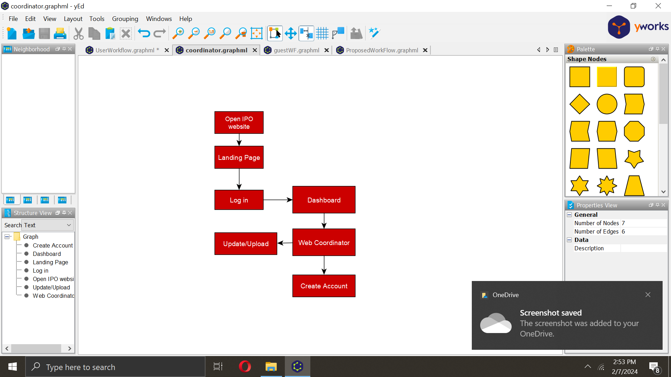

*Figure 2.2.4 Proposed Workflow of the College Coordinator*

Figure 2.2.4 above shows the proposed workflow of the college coordinator. It begins with the user visiting the IPO website and logging in. Then can manage the IP for their college. This includes creating accounts, validate user accounts and managing users within their college.

*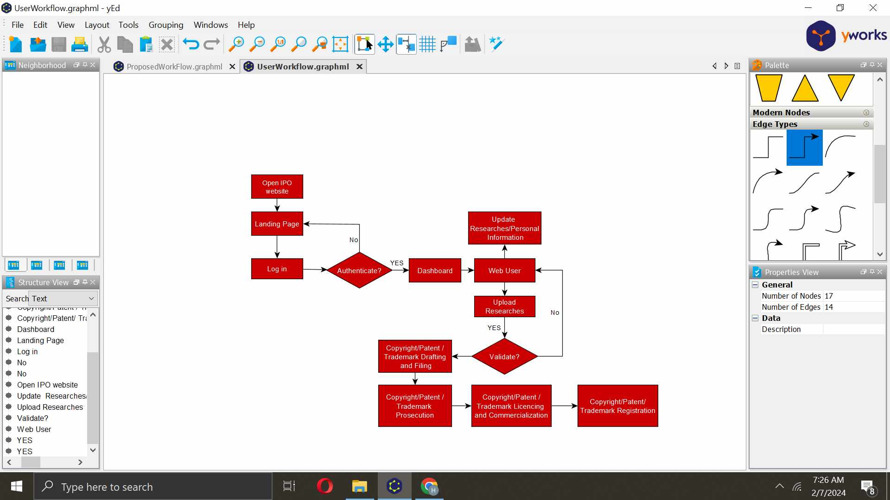Figure 2.2.5 Proposed Workflow of the User*

Figure 2.2.5 above shows the proposed workflow of the user. Begins with the user visiting the IPO website and logging in. Once the user is authenticated, they can access the dashboard to manage their intellectual property (IP). Then user can view and update their profile information, as well as their research and access resources that have been granted to them by the admin or college coordinator. This may include the ability to upload research. The college coordinator will validate the uploaded research and then the IPO process the applications. Once approved, the IP will be granted to the user.

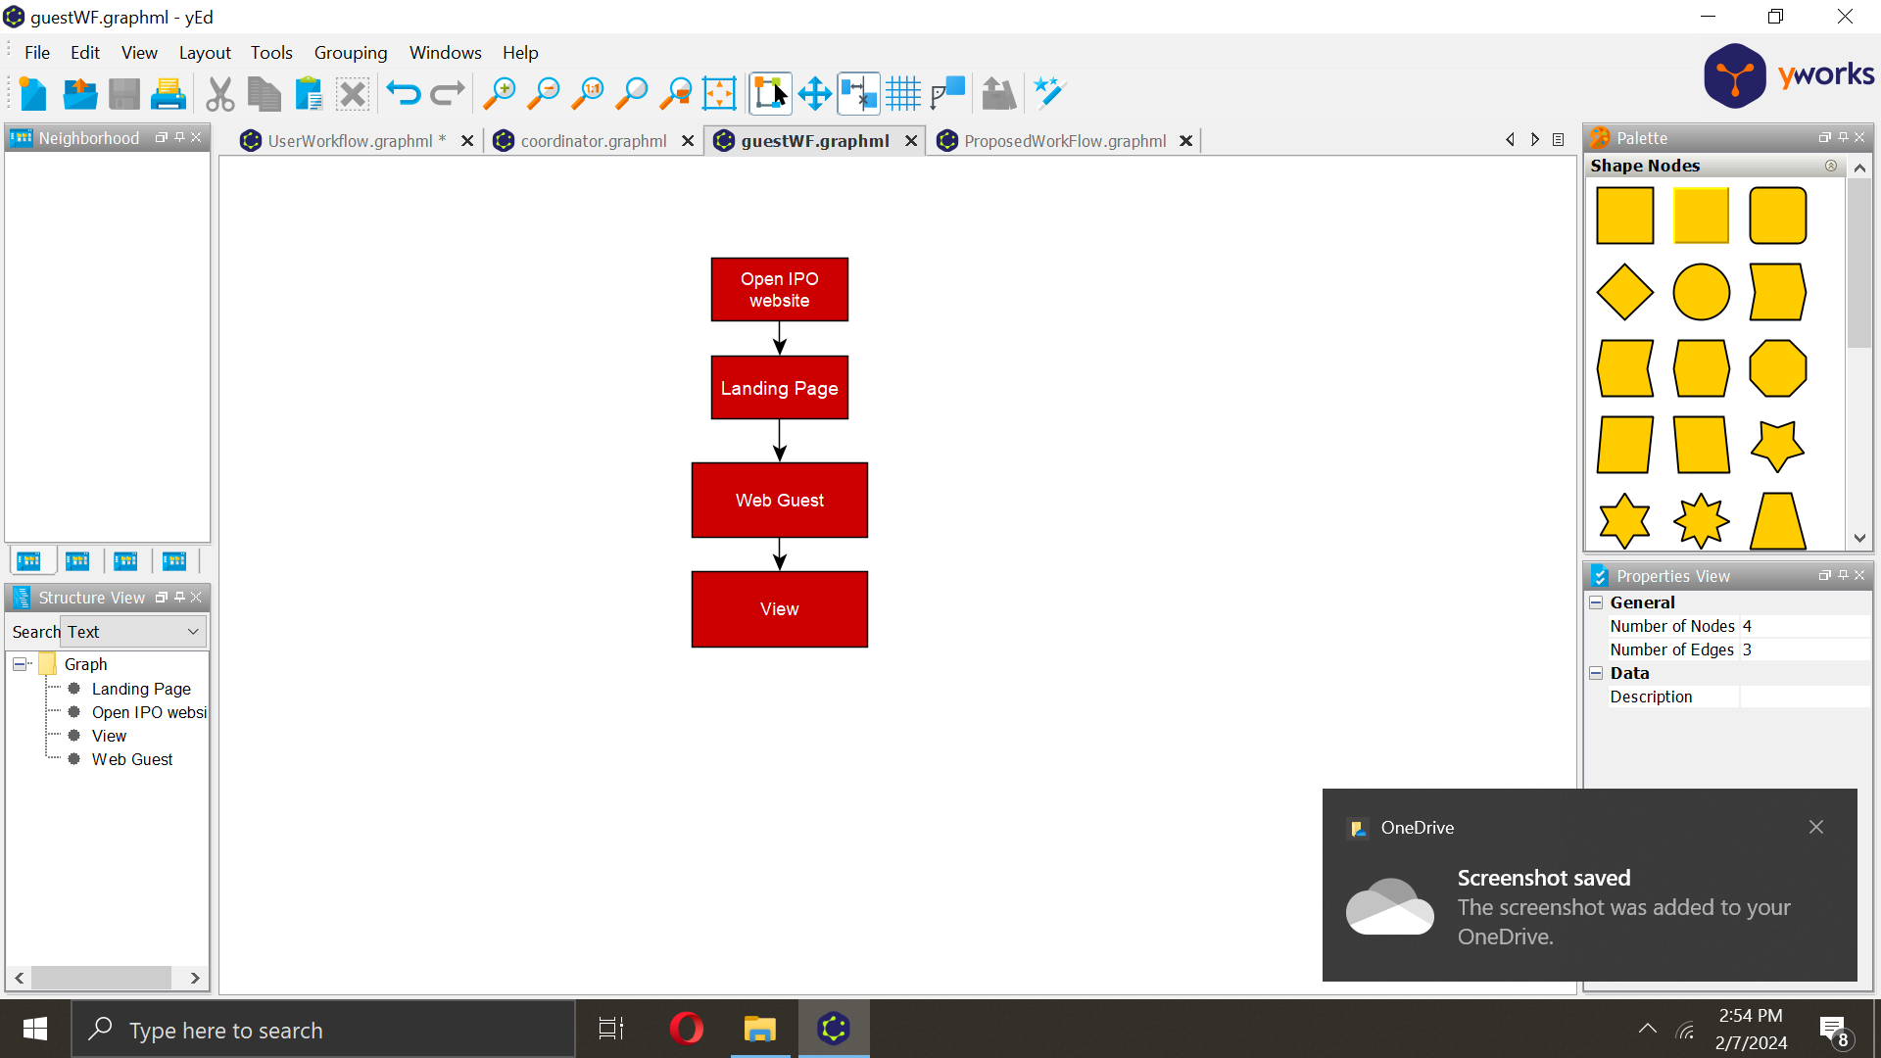

*Figure 2.2.6 Proposed Workflow of the Guest*

Figure 2.2.6 above shows the proposed workflow of the guest. It begins with visiting the IPO website. The guest can only view public resources. This may include information about the IPO and the IP data – only abstract.

## **2.2 Review of Related Systems**

The following related systems gave the proponents an idea about the process of storing, protecting, and managing all of Mindanao State University’s intellectual property assets including patents, trademarks, copyrights, and trade secrets through the system during the development of the system.

### 2.2.1 Digital Public Library of America

 *Figure 2.3.1 Digital Public Library of America Homepage*

The DPLA's website provides a single access point to millions of digital items from libraries, archives, museums, and other cultural heritage institutions across the United States. The DPLA's collection includes a wide range of materials, including photographs, manuscripts, maps, books, newspapers, films, and sound recordings.

The DPLA's website offers a variety of features to help users explore and discover its collection. Users can browse by topic, search for specific items, or view curated exhibitions and primary source sets. The DPLA also offers a variety of educational resources for students, teachers, and researchers.

The feature that we will use in the proposed project, which is like the feature of DLPA, is categorization by topic; it involves classifying content, data, or information into distinct categories or topics. Each category represents a specific subject area or theme. This metadata helps the system organize and categorize the items correctly.

### 2.2.2 ACM Digital Library

*Figure 2.3.2 ACM Digital Library Homepage*

The ACM Digital Library (DL) is a comprehensive digital collection of computing literature. It contains over 7 million full-text articles from ACM journals, conference proceedings, technical magazines, and books. The DL also includes the ACM Guide to Computing Literature, a bibliographic database that indexes over 6 million computing publications.

The ACM Digital Library is a valuable resource for students, researchers, and practitioners in the field of computing. It provides a single access point to a wide range of high-quality computing literature. The DL is also easy to use and navigate.

The feature that we will be adopting is similar to the web-based system of ACM digital library, the search bar, it is typically located prominently on the website's homepage or at the top of the page for easy access. Users can enter keywords, phrases, or queries related to their research interests or topics of study into this search bar. This allows them to specify additional search criteria, such as author names, publication dates, or specific publication titles, to narrow down their results.

2.2.3 University of the Philippines- Diliman Library  
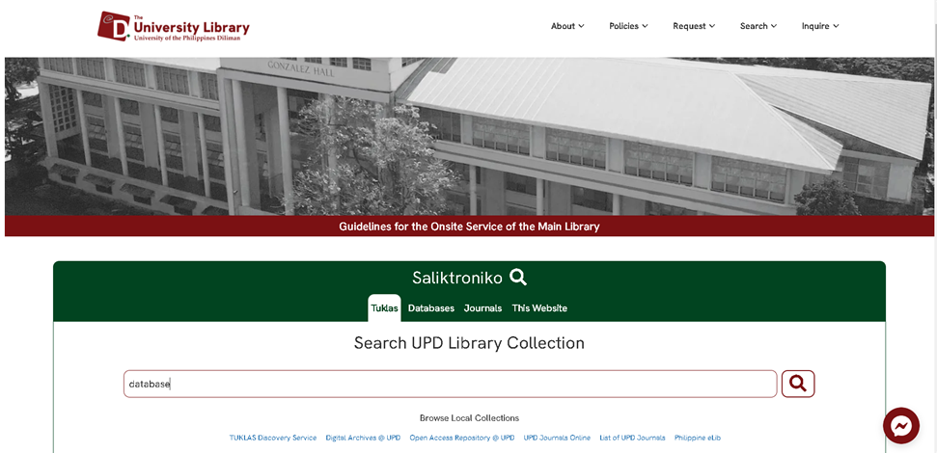 *Figure 2.3.3 University of the Philippines- Diliman Library Homepage*

The UP Diliman Library is a comprehensive academic library that provides access to a vast collection of print and digital resources across various disciplines. It serves as the primary information hub for the UP Diliman campus, offering a wide range of services and resources to support teaching, learning, and research activities. And its central academic and research library that serves the University of the Philippines Diliman campus community in Quezon City, Philippines. It plays a crucial role in supporting the educational and research needs of students, faculty, and researchers.

The features that we are adapting based on the University of the Philippines- Diliman Library website is the repository of the IP assets; the website may serve as a repository or database where various types of intellectual property assets are cataloged and organized. This could include patents, research papers, copyrighted materials, and trademarks.

### 2.2.4 Digital Commons- University of South Florida

*Figure 2.3.4 Digital Commons- University of South Florida Homepage*

It is a digital repository that serves as a platform for preserving, showcasing, and disseminating scholarly and creative works produced by faculty, students, and researchers affiliated with the university. It provides a central location where users can access a diverse range of materials, including research articles, theses and dissertations, conference proceedings, open-access journals, student publications, and other types of digital content.

The feature that will be adopted is forum inquiries, users can use this feature to reach out to authors for various purposes, including asking questions, seeking clarifications, requesting additional information, or expressing interest in collaboration on related research or projects.

### 2.2.5 Internet Archive

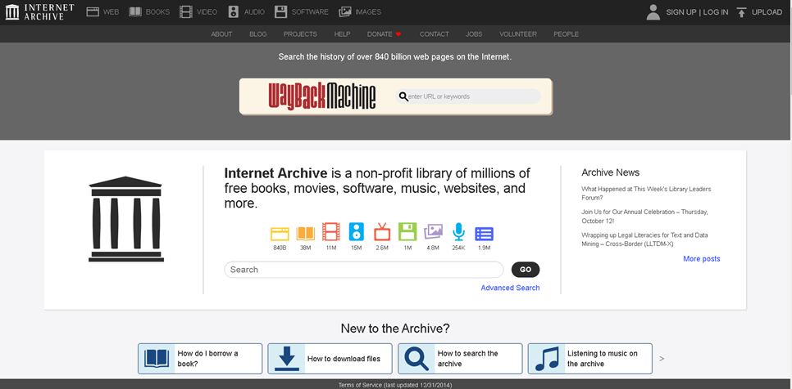 *Figure 2.3.5 Internet Archive Homepage*

Internet Archive is a digital library with a mission to provide "Universal Access to All Knowledge." It seeks to archive and make accessible a wide range of digital content from the internet and beyond. The Internet Archive's most well-known tool is the "Wayback Machine," which allows users to access archived versions of websites dating back to the early days of the World Wide Web. Most of the content on the Internet Archive, including archived websites, books, audio, video, and other materials, can be freely accessed by anyone without the need for a user account.

The features that we are adapting similar to this system is, that users who wish to contribute their digital content, such as books, audio recordings, or videos, to the Internet Archive's collections may need to create accounts. This allows them to upload, manage, and describe their contributions effectively. Account holders can create and curate collections within the Internet Archive, organizing content around specific themes, subjects, or interests.

The features of login and sign-up can be useful for the proposed project.

## **2.3 Summary of Related Systems**

| **Related Systems** | **User-friendly Interface** | **Document Tracking** | **Forum Inquiries** | **Reporting and Analytics** | **Manage IP Assets** | **Log in**  **and**  **Log out** | **Search IP Assets** |
| --- | --- | --- | --- | --- | --- | --- | --- |
| **Digital Public   Library of America** | **✓** |  |  |  |  |  | **✓** |
| **ACM Digital Library** | **✓** |  |  |  |  | **✓** | **✓** |
| **University of the Philippines - Diliman Library** | **✓** |  |  |  | **✓** |  |  |
| **Digital Commons- University of Florida** | **✓** |  | **✓** |  |  |  |  |
| **Internet Archive** | **✓** |  |  |  |  | **✓** |  |
| **IPDMS** | **✓** | **✓** |  | **✓** | **✓** | **✓** | **✓** |

*Table 2.3 Summary of Related Systems*

# **Chapter 3**

## **Methodology**

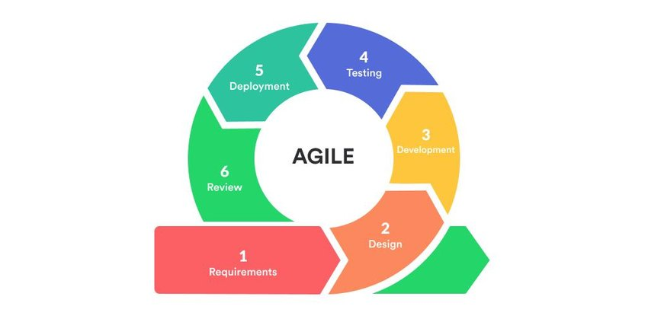The researcher will be using the agile model as a methodology for the development and implementation of the system. Agile allows for iterative development, where requirements and solutions evolve through collaboration between self-organizing, cross-functional teams.

*Figure3 Agile Methodology*

Figure 3.1 shows the agile model. First, researchers set clear goals and interviewed the TIC – Manager asking what functions and constraints to expect from the system. After collecting the data, the requirements of the system were defined and analyzed. Subsequently, during the design phase, they iteratively develop a flexible research plan to accommodate evolving needs. As the project progresses into development, researchers execute the plan, staying responsive to emerging challenges. Following development, rigorous testing ensures the validity and reliability of research findings. Upon successful testing, deployment disseminates the findings to stakeholders and the academic community. Finally, in the review phase, researchers reflect on the entire research adventure, identifying areas for improvement and informing future endeavors.

## **3.1 Requirements Analysis**

### 3.1.1 Data Gathering

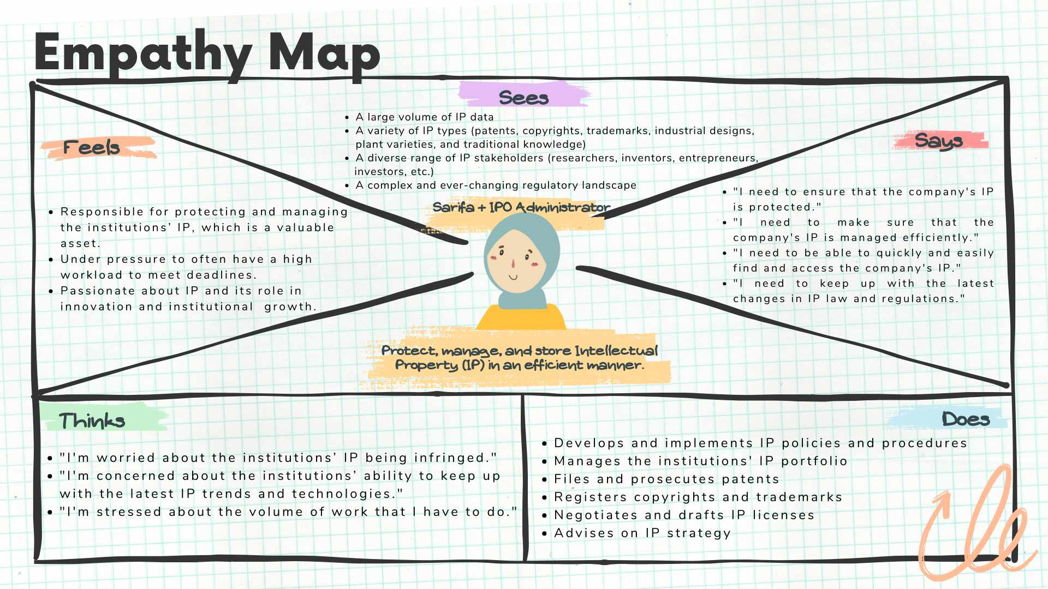 The data for this project was gathered by conducting interviews with the office of Mindanao State University Marawi - Intellectual Property Office under the Technology and Innovation Center. The researchers utilized face-to-face interviews with the client to develop an empathy map, gathering insights into their feelings, observations, thoughts, expressions, and actions related to intellectual property data.

*Table 3.1.1 Empathy Map – Data Gathering*

The figure shows the empathy map of the client who will use this web-based application.

### 3.1.2 PIECES Evaluation Framework

In this section, the evaluation is conducted using the PIECES Framework, which served as the basis for identifying deficiencies in the current system. The PIECES Framework comprehensively analyzes various aspects of the system, including Performance, Information, Economy, Control, Efficiency, and Service. This structured approach facilitates a thorough examination of the system's strengths and weaknesses, shedding light on areas where improvements can be made. The identification of deficiencies using the PIECES Framework serves as a valuable foundation for subsequent enhancements and optimizations within the current system.

|  |  |
| --- | --- |
| **P**erformance | The system may be slow to respond to queries, making it difficult for users to find the information they need. And may crash or experience other errors, making it unavailable to users. |
| **I**nformation | Intellectual property assets may be lost or corrupted. |
| **E**conomy |  |
| **C**ontrol/Security | The system stores sensitive intellectual property data, which could make it a target for hackers. If the system is not properly secured, it could be compromised, which could lead to data breaches and performance problems. |
| **E**fficiency | IPDMS is not regularly updated with new features and bug fixes, it could become outdated and inefficient. This could lead to performance problems and security vulnerabilities. |
| **S**ervices | Difficult to maintain and upgrade the system, which could lead to performance problems, or the services offered. |

*Table 3.1.2 PIECES Evaluation Framework*

### 3.1.3 Cause and Effect Analysis

Based on the PIECES Evaluation Framework, an assessment of the causes and effects of the problems within the current system has been conducted. This summary outlines the identified causes and effects within the PIECES Framework and proposes corresponding solutions to address the issues. The evaluation serves as a foundation for understanding the intricacies of the system's deficiencies and provides insights into the constraints associated with implementing proposed solutions.

|  |  |  |  |  |
| --- | --- | --- | --- | --- |
|  | Problem/Opportunity | Cause and Effect | System Objective | System Constraints |
| **Performance** | Website crash | **C-** Many users use the system simultaneously  **E**- difficult to access and it becomes unavailable for other uses | Optimizing server capacity, enhancing security protocols, and improving overall system resilience. | Limitations in scalability, make it difficult to accommodate sudden spikes in traffic or increased user activity. |
| **Information** | Loss and corrupted | **C-** Failure to regularly backup and create redundant copies of intellectual property **E-** system failures, hardware malfunctions, or accidental deletions. | Identifying and addressing the root causes of data loss or corruption, whether they be due to hardware failures, software bugs, human error, or malicious activities. | Technological constraints, such as reliance on outdated hardware or software, may limit the ability to implement the latest features and encryption methods. |
| **Economy** |  |  |  |  |
| **Control/Security** | Attack by hackers | **C- C**yber-attacks can lead to unauthorized access, theft, or corruption of intellectual property stored digitally. **E**- Loss of sensitive information, potential misuse of IP, and damage to reputation. | Identify and neutralize the security breach, regaining control and preventing unauthorized access. | Human error constraints often contribute to successful hacking attempts. |
| **Efficiency** | Outdated | **C- F**ailure to regularly update software, operating systems, and applications.  **E-**Vulnerabilities to security threats, diminished performance, and compatibility issues with newer technologies. | Improve system responsiveness, reduce downtime, and enhance user experience. | Technical constraints arise from the interoperability issues between outdated systems and newer applications |
| **Services** | Difficult to maintain | **C**- Insufficient knowledge or expertise to upgrade or migrate to newer technologies. **E**- Limited scalability, challenges in adapting to changing needs, and potential operational inefficiencies. | Empowering the technical support team with the necessary training and resources to efficiently handle maintenance tasks. | The complexity of the system architecture can hinder efficient maintenance. |

*Table 3.1.2 Cause and Effect Analysis*

### No description available.3.1.3 Gantt Chart Development of Intellectual Property Data Management System

*Figure 4.1.4 Gantt Chart in developing the system*

Figure 3.1.3 shows the Gantt Chart development of the system. The system was proposed in mid-2023, the planning and data gathering began in the same month, followed by defining the project scope and designing the proposed workflow. Then, we proposed our chapter 1 followed by 2 and 3 in the week after to our adviser for review and revisions. And then, the potential proposal defense is scheduled for the last week of November or the first week of December. From early December 2024, the proponents began developing the system up until April 2024. The proponents started testing the system early in March while the system was under development. The system’s testing was completed in May 2024. The result and discussion of the project began in April and continued up to May.

## **3.2 Design**

This design provides modeling tools that describe the systems and their processes including developer and user specifications and software testing plans.

### 3.2.1 Hierarchical Input- Process- Output

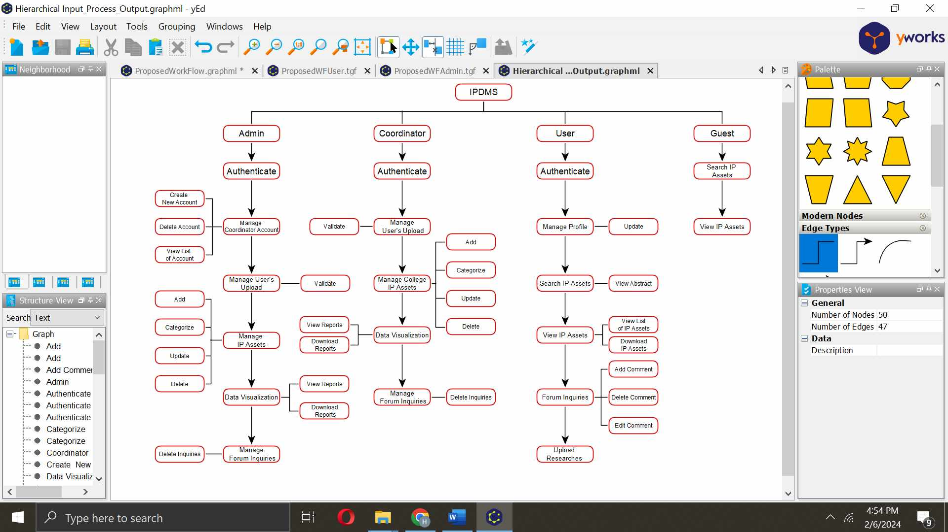

*Figure 3.2.1 Hierarchical Input-Process-Output*

The admin holds the responsibility for managing the accounts of coordinators and users. The admin oversees the management of IP assets, including updating and categorizing assets, viewing data visualization reports and their downloadable features. Additionally, the admin can manage user uploads by validating the IP assets that will be put into the system, and they can also manage forum inquiries. The admin has the authority to delete inappropriate comments and oversee the update logs, which reflect the detailed specifics of assets saved within the system.

The coordinator plays a crucial role in facilitating communication and ensuring smooth system operation. Coordinators are responsible for managing User accounts, reviewing, and approving User-submitted IP assets. And also, they can view also the data visualization reports and allows them to download the reports.

The User, as the primary beneficiary of the system, actively interacts with the platform to manage their IP assets. Users can submit new IP assets for review and approval and can view their existing assets. They can also access other works by others.

The Guest, with limited access, can view publicly accessible IP assets. While unable to submit or manage IP assets, Guests contribute to the system's overall engagement and knowledge exchange.

The hierarchical input-process-output model effectively outlines the distinct roles and responsibilities of each user category within the IP management system. This structured approach ensures clear communication, efficient task allocation, and seamless system operation.

### 3.2.2 Input-Process-Output

#### 3.2.2.1 Login  
  
  
 *Figure 3.2.2.1 Input-Process-Output for Account login on IPDMS*

Figure 3.2.2.1 above illustrates the Input-Process-Output for the account log-in process on the IPDMS web-based systems. Users are required to input their username and password. The system then authenticates the provided data. If the entered credentials exist in the system, the user is granted access to the system.

#### 3.2.2.2 Upload IP Assets

*Figure 3.2.2.2 Input-Process-Output for uploading IP Assets on IPDMS*

Figure 3.2.2.2 above illustrates the Input-Process-Output for uploading IP assets. Users can upload their intellectual property assets into the system. These uploads are then subject to validation by the administrator or coordinator. If the uploaded content is approved, it is automatically stored in the database.

#### 

#### 3.2.2.3 Update IP Assets by administrator and coordinator

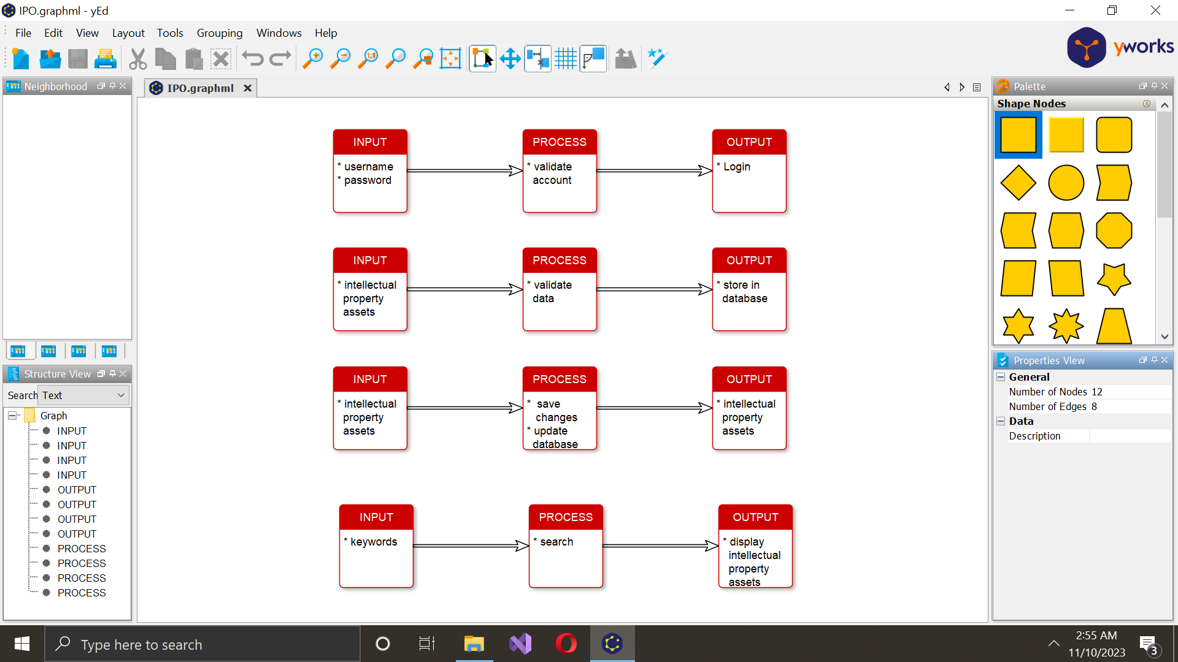  
  
 *Figure 3.2.2.3 Input-Process-Output for updating IP Assets on IPDMS*

Figure 3.2.2.3 above illustrates the Input-Process-Output for updating IP assets, a capability accessible to both coordinators and administrators. They can update, edit, and delete intellectual property works, and the revised information will be displayed within the system. This functionality ensures that coordinators and administrators can manage and showcase the latest versions or modifications to the intellectual property assets.

#### A screenshot of a computer Description automatically generated3.2.2.4 Search IP Assets

*Figure 3.2.2.4 Input-Process-Output for searching IP Assets on IPDMS*

Figure 3.2.2.4 above illustrates the Input-Process-Output for searching IP assets. Users can enter keywords related to what they want to search. After entering the keywords, the system will display a list of IP assets matching the search criteria. This feature enables users to easily locate and access the specific intellectual property assets they are looking for.

#### 3.2.2.5 Manage Profile

*Figure 3.2.2.5 Input-Process-Output for managing profile on IPDMS*

Figure 3.2.2.5 above illustrates the Input-Process-Output for managing profiles. In this system, users and coordinators can update their information, and any modifications made will be reflected automatically. This functionality ensures that individuals can easily manage and keep their profiles up to date.

#### 3.2.2.6 Add comments by user

*Figure 3.2.2.6 Input-Process-Output for adding comments.*

Figure 3.2.2.6 illustrates the Input-Process-Output for adding comments. Users have the capability to input comments on various content. The process involves the user entering their comments in the provided interface. The system then processes and stores the comments, associating them with the relevant content.

### No description available.3.2.3. Use Case Diagram

*Figure 3.2.3 Use Case Diagram*

This figure illustrates the use case diagram of the IPDMS. The admin features include managing accounts, managing IP assets, the admin can add, update, delete, and categorize the intellectual property assets that are added to the system. This comprehensive functionality empowers the admin to not only facilitate the inclusion of new assets but also to ensure that the existing assets are kept up-to-date and appropriately categorized for efficient organization and retrieval within the system. And can manage forum inquiries, in managing forum inquiries, the admin has the authority to delete comments that are not conducive to a positive environment for everyone. The forum serves as a collaborative space for users and researchers, fostering interaction and knowledge exchange. The admin's ability to moderate and remove inappropriate comments ensures a conducive and respectful platform for productive collaboration within the community. The upload logs feature serves as a historical record of when and where assets are added to the system, along with detailed information about each upload. This functionality allows administrators and coordinators to track the progression of asset uploads, providing transparency into the system's activity. And, they can access the data visualization reports at the same time they can download the reports. Administrators can review the timeline and specific assets added, and the feature also contributes a comprehensive understanding of the system's history and facilitates effective management and analysis of intellectual property assets. The validator, like the admin, can manage user accounts, handle IP assets, manage forum inquiries, and upload logs. Users can manage their profiles, search for IP assets for viewing, add, edit, and delete content in the forum section. Additionally, users can upload assets, but approval is required from the validator or administrator. And the users can download the forms like the non-disclosure agreement and different forms that are needed to fill out. This comprehensive use case diagram outlines the functionalities and interactions among admins, validators, and users within the IPDMS.

### A screenshot of a computer Description automatically generated3.2.4. Entity-Relationship Diagram

*Figure 3.2.4 Entity-Relationship Diagram*

The ERD diagram for the Intellectual Property Database Management System (IPDMS) at Mindanao State University comprises entities such as Intellectual Property types (Copyright, Patent, Trademark), Admin, Person, Department, Account, Comment, Approved IP, Forms, Search and College. Intellectual Property encapsulates submitted works, each associated with a specific Intellectual Property type. Admin, with overarching authority, manages Coordinators, Users, Intellectual Property, and Comments. Users, the regular contributors, engage in asset submissions and forum discussions. Comment or Forums serve as collaborative spaces. This ERD captures the detailed relationships and interactions, illustrating the dynamic flow of information and collaboration within the IPDMS ecosystem.

### 3.2.5. Architectural Design

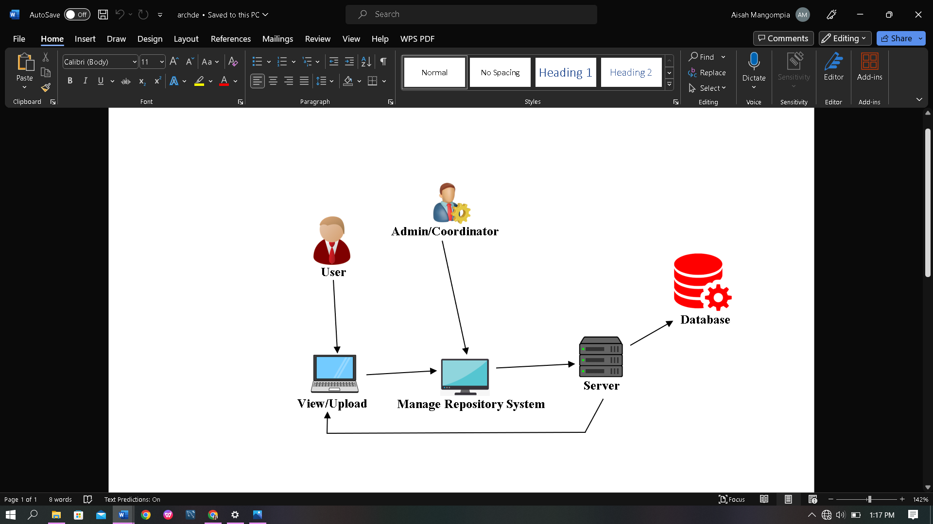

*Figure 3.2.5 Architectural Design of IPDMS*

Figure 3.2.5 illustrates the Admin/Coordinator and User/Researcher architecture. All the users have access to the database when storing and querying data. The Admin/Coordinator is responsible for managing the repository system, which includes creating and managing users, uploading, and deleting IP assets, and managing the database. The User/Researcher can view and upload research to the repository system.

**3.3 Development and Testing**

This section discusses the test plan, the software, and the hardware specifications that are used in the development and testing of the system.

### 3.3.1. Software Specification

|  |  |
| --- | --- |
| **Name** | **Description** |
| Operating System (OS) | Windows 10 |
| Programming Language | C#, JavaScript, CSS, HTML, PHP |
| SQL Database | MySQL |
| Web Server | XAMPP |
| System Type | 64bit |
| Editor | Notepad++, Sublime, VS Code |
| Web Browser | Google Chrome, Microsoft Edge |

*Table 3.3.1 Developer’s Software Requirement*

Table 3.3.1.a shows the software specification for the developer and user. It also shows the minimum software requirement for the end user.

|  |  |
| --- | --- |
| **Name** | **Description** |
| Operating System (OS) | Windows 7 |
| System Type | 32bit or 64bit |
| Web Browser | Google Chrome/Microsoft Edge |

*Table 3.3.1.b**User’s Software Requirements*

Table 3.3.1.b shows the user's software requirement. The user must have at least a Windows 7 operating system, a system type of either 32bit or 64bit, and a browser preferably, Google Chrome browser.

### 3.3.2. Hardware Specification

|  |  |
| --- | --- |
| **Name** | **Description** |
| Processor | 2.60 GHz |
| Memory (RAM) | 4 GB |
| Storage | 128 GB |
| Data Connectivity | Local Area Network |

*Table 3.3.2.a Developer’s Hardware Requirements*

Table 3.3.2.a shows the hardware specifications of the laptop for the developer.

|  |  |
| --- | --- |
| **Name** | **Description** |
| Processor | Intel Core i3 or better |
| Memory (RAM) | 3GB or better |
| Storage | 500 GB or higher |
| Data Connectivity | Local Area Network |

*Table 3.3.2.b User’s Hardware Requirements*

Table 3.3.2.b shows the user's hardware requirement. The user must comply with the recommended requirements to experience better usage of the project.

### 3.3.3. Deployment Diagram

*Figure 3.3.5 Deployment Diagram*

In Figure 3.3.5, the deployment diagram illustrates the cohesive interaction among various components within the Intellectual Property and Data Management System (IPDMS) architecture. The user's browser serves as the primary interface, facilitating user interactions with the system, allowing access to intellectual property assets, and enabling the submission of inquiries. The modem acts as the intermediary, ensuring a smooth data transfer between the user's browser and the broader network, whether it be the internet or an intranet. The internet/intranet, representing the network infrastructure, functions as the communication medium, facilitating data exchange between the user's browser, the application server, and the database server.

The application server, a pivotal component, hosts and executes the functionalities of the IPDMS. It processes user requests, manages data retrieval and storage, and oversees the overall system functionality. Simultaneously, the database server, a critical repository, stores and manages intellectual property assets, user data, and other relevant information, contributing to data persistence and retrieval. The seamless flow of functions involves users interacting with the system through their browsers, with data transmission via the modem to the internet/intranet. The application server processes user requests, communicates with the database server for data retrieval or storage, and sends relevant information back to the user's browser. This integrated architecture ensures efficient user access, management, and contribution to intellectual property assets within the IPDMS.

### 3.3.4. Test Plan

In this section, demonstrates the test plan for conducting a usability test concerning the Web-Based Intellectual Property Data Management System in Mindanao State University - Marawi Campus. The usability testing of the system is required to access the usefulness, satisfaction and efficiency based on the user’s data.

#### 3.3.4.1 Usefulness, Satisfaction and Ease of Use- USE

The USE questionnaire, developed by Lund in 2001, is designed to assess the subjective usability of a product or system. This survey consists of 30 items and evaluates four key dimensions of usability: usefulness, ease of use, ease of learning, and satisfaction.

For this project, we'll create a USE questionnaire to gauge users' perceptions regarding usefulness, satisfaction, and ease of use. These factors are important as they influence the system's performance.

#### 3.3.4.2 USE Questionnaire – Based on Lund, A.M. (2001) Measuring Usability with the USE Questionnaire

*Figure A 3.3.6.2 USE Questionnaire*

*Figure B 3.3.6.2 USE Questionnaire*

Figure A and Figure B shows the 30 items questions that evaluates the system performance by determining the usefulness, ease of use, ease of learning and satisfaction.

#### 3.3.4.3 Usefulness, Satisfaction and Ease of Use- USE Evaluation

The USE (Usefulness, Satisfaction, Ease of Use) method for evaluating usability is different from other testing approaches because it doesn't generate a single numerical score. Instead, it looks at various aspects like usefulness, satisfaction, and efficiency to assess the usability. This method might include qualitative analysis of user’s feedback, such as surveys and interviews. By using the USE method, designers and researchers can really understand how usable the system is and figure out how to make it better for users.

**DEFINITION OF TERMS:**

* **‌Intellectual Property (IP)** – refers to creations of the mind, such as inventions, literary and artistic works, designs, symbols, names, and images used in commerce. It is protected by law through patents, copyrights, trademarks, and trade secrets.
* **Data Management** – involves the process of organizing, storing, and handling data throughout its lifecycle. It includes practices related to data quality, retrieval, and overall efficient use.
* **Trademark** – a recognizable sign, design, expression, or symbol that identifies products or services of a particular source, distinguishing them from others in the market.
* **Copyright** – is a legal right that grants the creator of an original work exclusive rights to its use and distribution, usually for a limited time, to enable the creator to receive compensation for their intellectual investment.
* **Patent** – an exclusive right granted for an invention, providing the inventor with the right to exclude others from making, using, selling, or importing the patented invention for a limited period.
* **Web-Based** – refers to systems, applications, or services that are accessible and operated through a web browser over the internet, allowing users to access them remotely.
* **IPDMS (Intellectual Property Data Management System)** – refers to a specialized system designed to centralize, store, and manage intellectual property assets, such as patents, trademarks, copyrights, and trade secrets.
* **Mindanao State University - Marawi Campus** – refers to the specific campus location of Mindanao State University, emphasizing the geographical context of the project.

**REFERENCES:**

1. AE Monge and CP Elkan, "An adaptive and efficient algorithm for detecting approximately duplicate database records", Proc of the Sigmod., vol. 2001, no. 03.
2. A Monge and C. Elkan, "An efficient domain independent algorithm for detecting approximately. duplicate database records", Proc. of the SIGMOD Workshop on Data Mining and Knowledge. Discovery, 1997.
3. Alokluk, J. (2019). Archiving and Document Management at Taibah University: A Case

Study. Computer and Information Science, 12(4), 11.

1. Cruz, C. (2017). Arts and Culture: Heritage, Practices and Futures Intellectual Property of

Indigenous Peoples (IP of IP): Challenges in Protecting Traditional Knowledge in the Philippines.

1. “History | IPOPHL,” *Ipophil.gov.ph*, 2023. <https://www.ipophil.gov.ph/history/>.
2. Jost Zetzsche. (2019). Freelance translators’ perspectives. Routledge EBooks, 166–182.
3. Lund, A. M. (2001). Measuring Usability with the USE Questionnaire. Usability Interface, 8(2), 3-6.
4. M. A. Hernandez and S. J. Stolfo. Real-world data is dirty: Data cleansing and the merge/purge problem. Data Mining and Knowledge Discovery, 2(1):9–37, 1998.
5. “Mandate & Function | IPOPHL,” *Ipophil.gov.ph*, 2023. <https://www.ipophil.gov.ph/mandate-function/>.
6. Republic Act No. 8293 | GOVPH. (1997, June 6). Retrieved December 2, 2023, from Official Gazette of the Republic of the Philippines website.
7. The link between intellectual property rights, innovation, and growth: A meta-analysis. Economic Modelling, 97, 196–209 | 10.1016/j.econmod.2021.01.019. (2021).
8. The Importance of Archive Management Systems in Digital Era. (2017). from Google Books website.
9. What is Data Management? (2020), from Oracle.com website.
10. What Is Intellectual Property, and What Are Some Types? (2023), from Investopedia website.
11. Sci-Hub | Psychometric Evaluation of the USE (Usefulness, Satisfaction, and Ease of use) Questionnaire for Reliability and Validity. Proceedings of the Human Factors and Ergonomics Society Annual Meeting, 62(1), 1414–1418 | 10.1177/154193121862132”
12. USE Questionnaire: Usefulness, Satisfaction, and Ease of use,” *Garyperlman.com*, 2024.